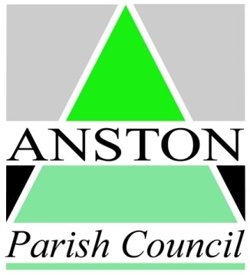**ANSTON PARISH COUNCIL**

**Application for Grant**

**B (Reduced Hall/Facilities Hire)**

**Please read the guidelines before completing this form. Use this form if you are a community group (or similar) requesting reduced rate or free use of parish facilities for a specific project, event or community activity. Use form A (Cash Grants) for larger projects. You may continue on a blank sheet if necessary, but please put the name of your organisation on any additional sheets. We prefer you to complete this form electronically by filling in the grey shaded text areas.**

**Your organisation**

**Please give us the following information about your organisation**:

Name of Organisation:

Address:

Post Code:

Provide brief description of the activities and main aims of your group in the box below:

How long has your organisation been in existence?

Does your organisation cover an area wider than the Parish of Anston? Yes  No

Please estimate number of Anston residents involved

Please specify if there are any restrictions to membership of your organisation (e.g. age group)

*Please note that the council will not normally fund applications from organisations with heavily restrictive membership criteria. Projects should be accessible, within reason, to any resident of the parish.*

**Contact Details (for this application)**

Name of contact:

Position:

Address for correspondence (if different from above):

Post Code:

Tel:

Email:

**Your Application**

What are you requesting? Please describe what you will you use the parish hall or other parish facilities (please specify) for.

Remember that the legislation governing grants means that the Council can only fund projects that can be shown to benefit the area or people living in it. Therefore you should explain how the grant would benefit people living or working in Anston.

Have you made any grant application to any other body for grant aid this year? Yes  No . If yes please give details:

|  |  |  |  |
| --- | --- | --- | --- |
| **Name of organisation applied to** | **Amount applied for** | **Date of Application** | **Amount Received** |
|  |  |  |  |
|  |  |  |  |
|  |  |  |  |
|  |  |  |  |

If you have received any other sources of funding in the past year (e.g. membership subscriptions etc.) not specified above, please give details:

**Additional Information**

Are there any other comments you wish to make to support this application? Please give this information below, or attach a separate sheet.

**Your Financial Situation**

All applications must be accompanied by the following financial information: **If you do not supply this information your application may not be considered unless previously agreed in writing by the Council.**

* A copy of your latest approved statement of income and expenditure or other financial report which indicates your financial position, or
* Photocopy of bank statements covering the past six months, or
* For newly-formed groups, with no Accounts to date, a copy of your written constitution.

**If you are unable to supply this information, please contact the Parish Council for advice before submitting this application.**

**Signed:****Date:**

**Please return to:**

**Grant Applications, Anston Parish Council, Council Offices, 15A Ryton Road. North Anston, Sheffield S25 4DL.**

**If you have any queries or for advice, please contact the Clerk on 01909 560922 or email** [**clerk@anston.gov.uk**](mailto:clerk@anston.gov.uk)**. The office is open Monday to Friday from 9.00am to 12.00pm. You can also submit this form electronically using the same email address.**